**Privacy Notice April 2018**

Being transparent and providing accessible information to individuals about how we use personal information is a key element of the Data Protection Act 1998 and the General Data Protection Regulation (Regulation (EU) 2016/679). The most common way to provide this information is in a privacy notice.

**Data Controller**

**Fleximinder Preschool Limited** is registered as a data controller with the Information Commissioner's Office Registration reference: **ZA283876**

Contact details for the data controller are:

Fleximinder Preschool Limited, 30 Turner Avenue, Lostock Hall, Preston, PR5 5LW.

Email: fleximinderpreschool@outlook.com

**Purpose of Processing Personal information**

As a Nursery School / Playgroup / After School Club, Fleximinder delivers services to you. In order to do this in an effective way we will need to collect and use personal information about you.

The Data Protection Act 1998 and the EU General Data Protection Regulation ensure that we comply with a series of data protection principles. These principles are there to protect you and they make sure that we:

* Process all personal information lawfully, fairly and in a transparent manner.
* Collect personal information for a specified, explicit and legitimate purpose.
* Ensure that the personal information processed is adequate, relevant and limited to the purposes for which it was collected.
* Ensure the personal information is accurate and up to date.
* Keep your personal information for no longer than is necessary for the purpose(s) for which it was collected.
* Keep your personal information securely using appropriate technical or organisational measures.

**Consent**

We will usually seek your consent prior to processing or sharing your information, however, if there is a legal reason, as outlined under the Data Protection Act 1998, the General Data Protection Regulations (GDPR) or any other appropriate legislation, we may not require your consent, e.g. where the disclosure is necessary for the purposes of the prevention and/or detection of crime. Where we need to disclose sensitive or confidential information such as medical details to other partners, we will do so only with your prior explicit consent or where we are legally required to so. We may disclose information when necessary to prevent risk of harm to an individual.

**Reasons/purposes for processing information**

We process personal information to enable us to provide childcare, encourage and supervise educational play, to advertise our services, to maintain our own accounts and records and to support and manage our staff.

**Type/classes of information processed**

We process information relevant to the above reasons/purposes. This may include:

* personal details
* family details
* GP contact details
* lifestyle and social circumstances
* digital images of the child's progress
* financial details
* education and employment details
* goods or services provided

We also process sensitive classes of information that may include:

* physical or mental health details
* racial or ethnic origin
* religious or other beliefs
* trade union membership

**Who the information is processed about**

We process personal information about:

* our employees
* the children in our care
* advisers, complainants, enquirers
* suppliers

**Information Sharing**

We sometimes need to share the personal information we process with the individual themselves and also with other organisations. Where this is necessary we are required to comply with all aspects of the Data Protection Act (DPA) and EU General Data Protection Regulations (GDPR). What follows is a description of the types of organisations we may need to share some of the personal information we process with for one or more reasons.

Where necessary or required we share information with:

* family, associates and representatives of the person whose personal data we
* are processing
* healthcare, social and welfare advisers or practitioners
* business associates
* financial organisations and professional advisers
* credit reference agencies, debt collection and tracing agencies
* education, educators and examining bodies
* current, past or prospective employers
* employment and recruitment agencies
* schools
* local and central government
* persons making an enquiry or complaint
* suppliers
* service providers

**Details of transfers to third country and safeguards**

Your personal and sensitive data will only be stored and processed on servers based within the European Economic Area (EEA).

**Retention Periods**

We will only keep your information for as long as it is required to be retained. The retention period is either dictated by law or by our discretion. Once your information is no longer needed it will be securely and confidentially destroyed.

Data retention requirements from the Companies Act 2006, The Childcare Act 2006 and The Chartered Institute of Personnel and

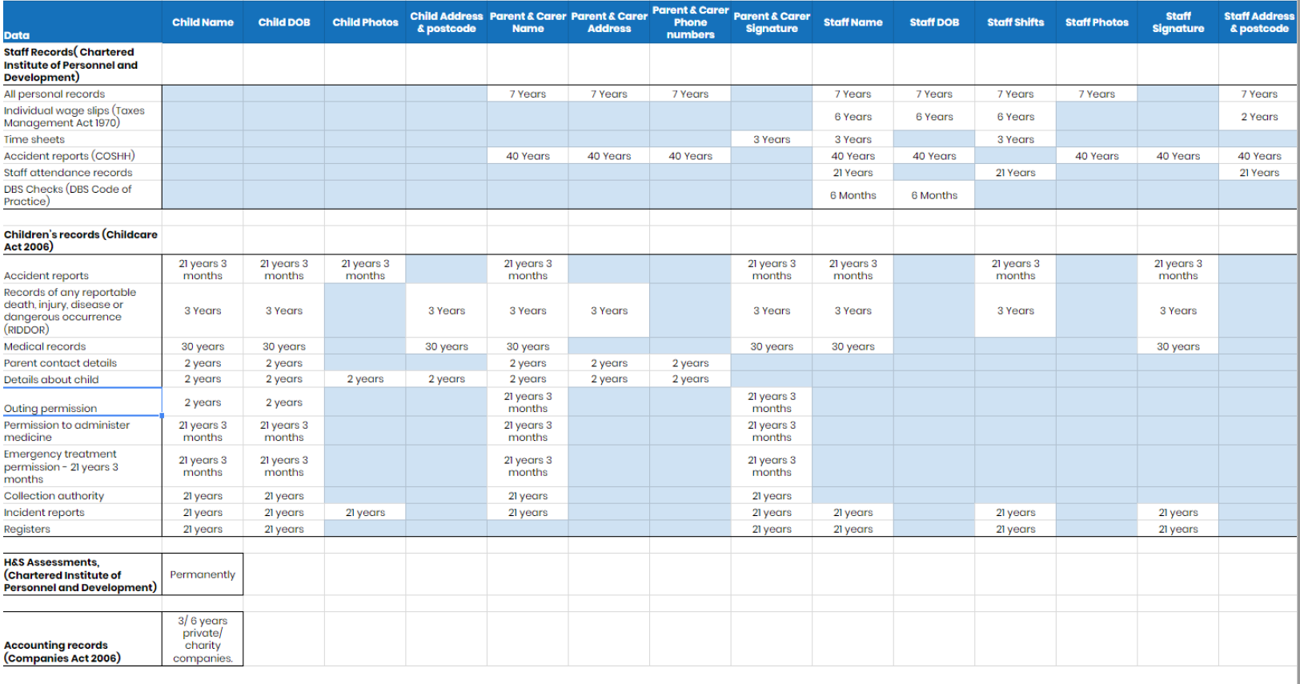

*A larger copy of this table is available up request by emailing [fleximinderpreschool@outlook.com](mailto:fleximinderpreschool@outlook.com)

**Your Rights**

You have certain rights under the Data Protection Act 1998 and the EU General Data Protection Regulations (GDPR), these are:

The right to be informed via Privacy Notices such as this.

The right of access to any personal information Fleximinder holds about yourself. To request a copy of this information you must make a subject access request in writing, either via a letter to Information Governance Fleximinder Preschool Limited, 30 Turner Avenue, Lostock Hall, Preston, PR5 5LW or via email to: fleximinderpreschool@outlook.com.

To ensure that we can deal with your request as efficiently as possible you will need to include your current name and address, proof of identity (a copy of your driving license, passport or two different utility bills that display your name and address), as much detail as possible regarding your request so that we can identify any information we may hold about you, this may include your previous name and address, date of birth.

Fleximinder does not charge for making a subject access request. You are entitled to receive a copy of your personal data within 40 calendar days of our receipt of your subject access request. This timescale will change to 1 calendar month in May 2018 due to the new General Data Protection Regulation (GDPR).

The right of rectification, we must correct inaccurate or incomplete data within one month.

The right to erasure. You have the right to have your personal data erased and to prevent processing unless we have a legal obligation to process your personal information.

The right to restrict processing. You have the right to suppress processing. We can retain just enough information about you to ensure that the restriction is respected in future.

The right to object. You can object to your personal data being used for profiling, direct marketing or research purposes.

**Access to Information**

Under the Freedom of Information Act 2000 and the Environmental Information Regulations 2004 you have a right to request any recorded official information held by Fleximinder.

If you need to make a request, it must be done in writing. You can:

Write to: Information Governance Fleximinder Preschool Limited, 30 Turner Avenue, Lostock Hall, Preston, PR5 5LW.

Email: [fleximinderpreschool@outlook.com](mailto:fleximinderpreschool@outlook.com)

You do not need to say why you want the information. Your request must include your name, and an address for correspondence (if you apply by email, your email address is a suitable address for correspondence). Please ensure you identify the information you want as clearly as possible.

With certain limited exceptions, you are entitled to a response within 20 working days.

It costs nothing to make a freedom of information request. However, Fleximinder can refuse to deal with your request if doing so would cost more than £450 (which equates to 18 hours' work)...

You may not get the information you asked for:

* If Fleximinder does not hold the information you have requested
* if the information is exempt from disclosure
* if finding the information you have requested would take longer than 18 hours

If we are unable to supply any of the information you have requested, we will tell you the reasons why.

**Information Security incident**

Should you wish to report an information security incident you can

Write to: Fleximinder Preschool Limited, 30 Turner Avenue, Lostock Hall, Preston, PR5 5LW.

Email: [fleximinderpreschool@outlook.com](mailto:fleximinderpreschool@outlook.com)

**Complaints, Comments and Compliments**

If you wish to make a compliment, comment or complaint about how Fleximinder are processing your data, then please send a compliment or comment or make a complaint to Fleximinder.

Write to: Fleximinder Preschool Limited, 30 Turner Avenue, Lostock Hall, Preston, PR5 5LW.

Email: [fleximinderpreschool@outlook.com](mailto:fleximinderpreschool@outlook.com)

If you are still dissatisfied with how Fleximinder have handled your complaint, you may contact the Information Commissioner's Office.

The Information Commissioner Wycliffe House Water Lane Wilmslow Cheshire

SK9 5AF

Phone: 08456 30 60 60 Website: [www.ico.gov.uk](http://www.ico.gov.uk)

Named Owner: Leah Ainsworth - Senior Information Risk Owner (SIRO)

Version Number: 1.0

Privacy Notice 2018

Date of Creation: 1st April 2018

Last Review: N/A

Next Scheduled Review: March 2019